`

[arpan.pal.campusdrive@gmail.com](mailto:arpan.pal.campusdrive@gmail.com)

[www.linkedin.com/in/arpan-pal-106102172](http://www.linkedin.com/in/arpan-pal-106102172)

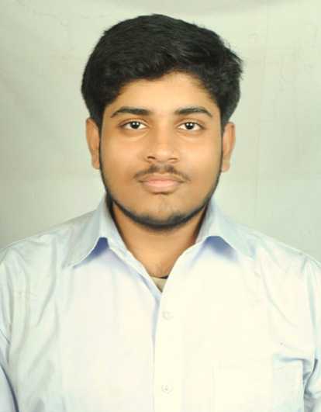

Electronics and Communication Engineer

ARPAN PAL

Chandannagar, Hooghly West Bengal - 712136

+918240498310

about me

**Date of Birth** : February 5, 1999

**Birth Place** : West Bengal, India

CAREER OBJECTIVE

I am an Analyst Trainee at Capgemini, seeking to find the opportunity to work in a fun and challenging working environment that will encourage me to improve and learn new and necessary skills, as well as be motivated by the company to do my best for the sake of helping myself and the company to advance in the software engineering industry.

**B. TECH**

Techno International New Town: *08/2017 – Present*

**XII - higher secondary**

Hooghly Collegiate School (WBCHSE): *2017*

**X - secondary**

Elite Co-Ed (WBBSE): *2015*

ACADEMIC BACKGROUND

**GPA – 9.08/10 (up to 7th Sem)**

**433/500 (86.60%)**

**629/700 (89.85%)**

Skills

* Good Leadership Skills
* Attentive Listening and Effective Oral Communication Skills
* Great at Problem Solving
* Ability to Quickly Create and apply Ideas and Solutions
* JAVA 8
* C Programming
* MAVEN
* HTML 5, CSS, JAVASCRIPT
* Analog & Digital Electronics & Circuit Design and Internet of Things

Programming SKILLS

**I hereby declare that the information provided above is true to the best of my knowledge.**

* **Eclipse IDE for Java Developers**
* **Oracle SQL Server**
* **Arduino IDE**
* **GitHub**
* **Adobe Premiere Pro**

Chandannagar, Hooghly

West Bengal – 712136

+918240498310

[arpan.pal.campusdrive@gmail.com](mailto:arpan.pal.campusdrive@gmail.com)

[www.linkedin.com/in/arpan-pal-106102172](http://www.linkedin.com/in/arpan-pal-106102172)

Basic Electronics, Microprocessors

C Programming, Data Structure & Algorithms, JAVA.

* **Domain Subjects :**
* **IT Subjects :**
* **Foreign Student Exchange Program** inSichuan Vocational College of Information Technology, **China**
* **“HTML CSS JavaScript”** by **The Johns Hopkins University**
* **“Algorithmic Toolbox”** by **University of California San Diego**
* **“Analog & Digital Electronics Circuit Design and Internet of Things”**
* **C Programming & Data Structures** from PCS Global
* **English** (Bilingual)
* **Hindi** (Bilingual)
* **Bengali** (Native and Bilingual)
* **Chinese** (Elementary)
* **PRAYAS – 2019**

“**UV LEDs in the Field of Sterilization Technology**”, Prayas – 2019, Second Edition, April 2019, pp. 53-56

(Awarded **“Editor’s Choice”** for the competition)

Softwares

SUBJECTS OF INTEREST

Languages

Publication

* Electronic Projects
* Photography
* Programming & Algorithms
* Video and Audio Editing
* Cricket
* Travelling

Electronics and Communication Engineer

ARPAN PAL



interests

Trainings & certifications



Arpan Pal